Exercise 5 – Mockito (Mocking + Stubbing)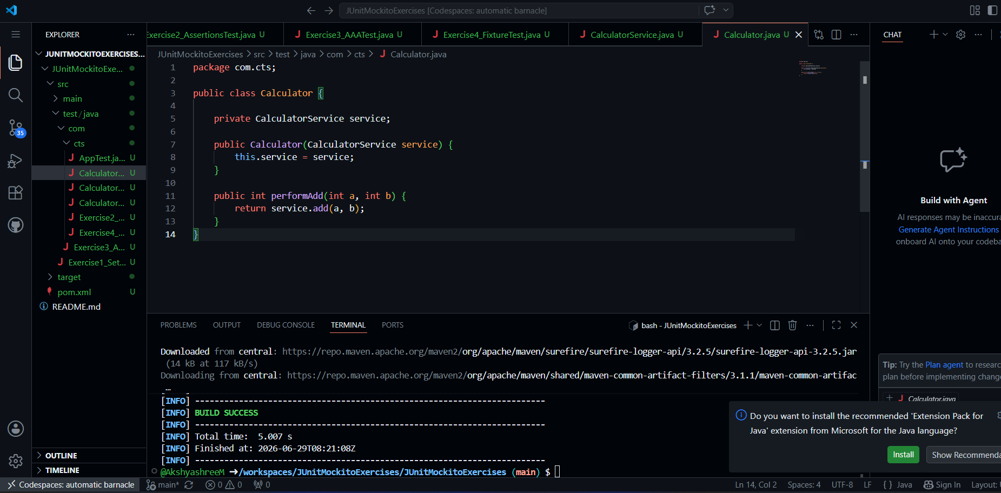
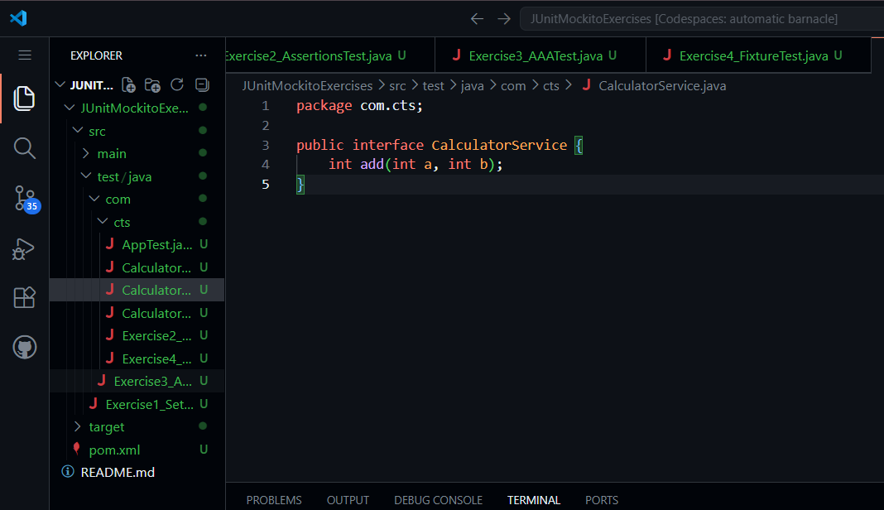
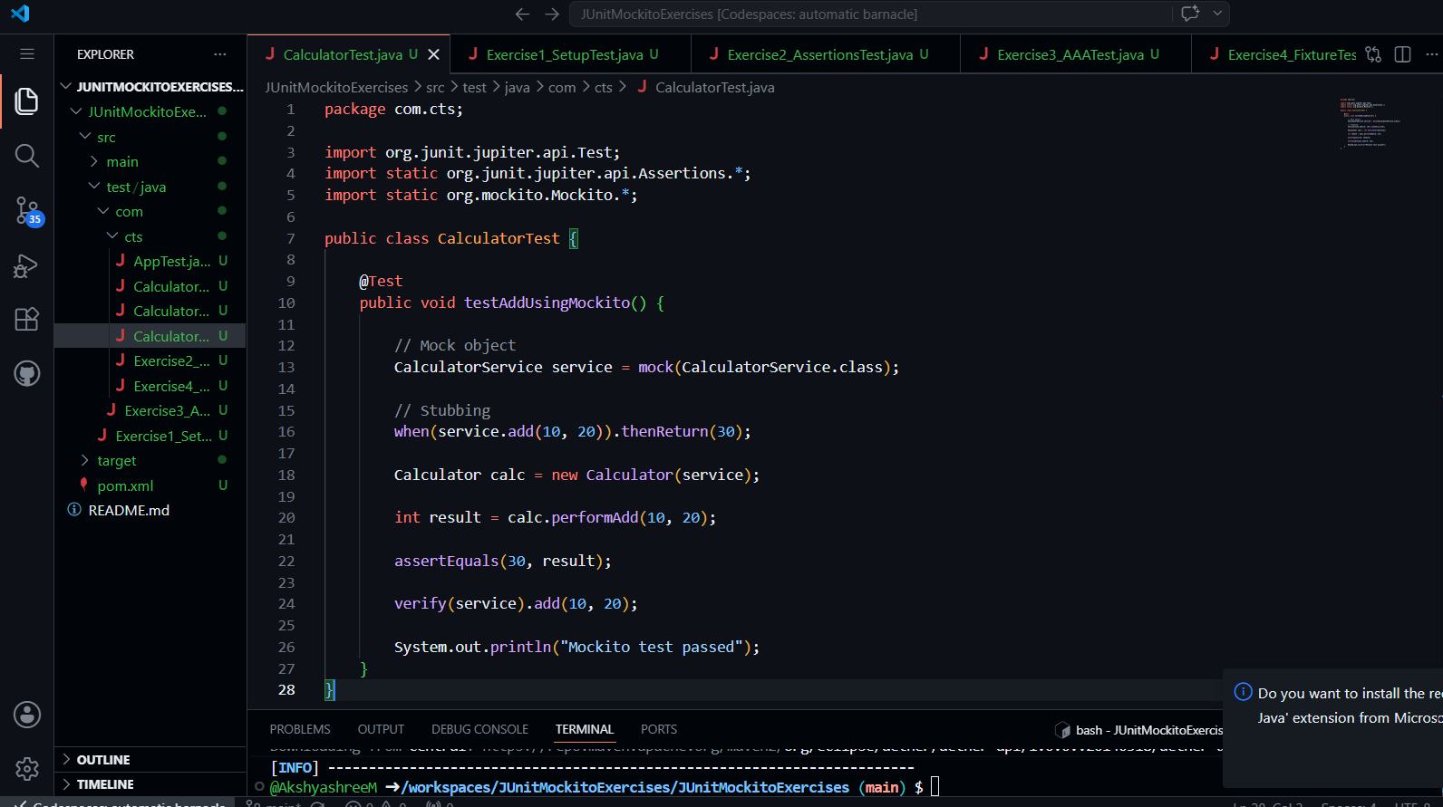
Exercise 2: Verifying Interactions (Mockito)
Code:
package com.cts;

import org.junit.jupiter.api.Test;
import static org.mockito.Mockito.*;

public class CalculatorVerifyTest {

@Test
public void testVerifyInteraction() {

CalculatorService service = mock(CalculatorService.class);

// call method manually (simulate usage)
service.add(5, 5);

// verify interaction
verify(service).add(5, 5);

System.out.println("Verification test passed");
}
}
